International symposium: Web-based smoking cessation aids for young people –
18.-19. September 2008 - Berlin

The smoking prevention programme of feelok

Padlina Oliver¹², Hofmann Tina¹, Jimmy Gerda²
¹Institute for Social- and Preventive Medicine of the University of Zurich
²Swiss Federal Institute of Sports Magglingen, Swiss Federal Office of Sports

In the first chapter, the most important aspects of the «feelok» project and intervention are discussed. The smoking prevention programme of feelok and some selected research results are presented in the second chapter.

The following table of contents gives an overview over the topics to be presented:

The «feelok» project and intervention 2
A multi-dimensional intervention 2
A multi-institutional intervention 2
An evidence-based intervention 3
The adolescents’ opinion about feelok 4
A school-based intervention 5
A transnational intervention 5
The profile of feelok users 5
A frequently used website 5
The dissemination strategies 5
The budget 7
The feelok smoking prevention programme and its empirical results 8
Percentage of smokers among the young population and among feelok users 8
Motivation to stop smoking and motivation to start smoking 9
The stage-matched intervention of the smoking prevention programme – Structure and user statistics 10
Stage-matched intervention, general information about smoking and the needs of the target group 15
The design of the effectiveness study of the smoking prevention programme 16
Other strategies to prevent smoking 17
Future outlook: The new smoking prevention programme - version 3 and the concept of „shared applications“ 19
Conclusion 20

The «feelok» project and intervention

The most important aspects of the feelok project and intervention are presented below.

A multi-dimensional intervention

www.feelok.ch is an internet programme for adolescents aged 12 to 18 aiming to promote health and well-being. Eleven topics are covered in feelok: alcohol, occupation, physical activity, cannabis, nutrition, love and sexuality, smoking, self-confidence and self-esteem, stress and suicide.

A multi-institutional intervention

feelok is a multi-institutional intervention, i.e. institutions that are renowned for their expertise in the respective field are responsible for the quality, evidence-based content and update of the programme on their topic. The partners are given a login and password which enables them to update the modules themselves.

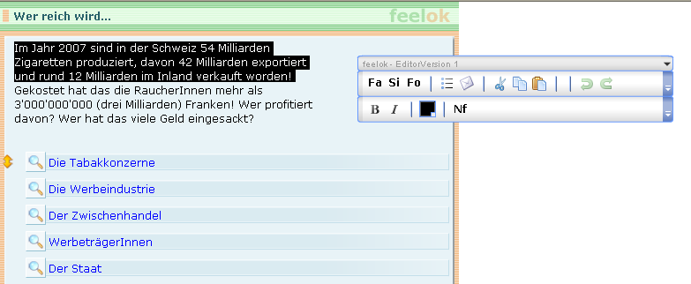
Fig. 1: With their individual login and password the partner institutions can update the content of the feelok programme themselves.

Several institutions support the dissemination of the intervention in various settings. Others provide financial support for the project or selected objectives. Some institutions conduct evaluation studies on certain aspects of feelok. The Institute of Social and Preventive Medicine at the University of Zurich is responsible for the co-ordination and evaluation of the intervention project as a whole and provides support to the partner institutions. The list of partner institutions can be found under www.feelok.ch/info.htm

This multi-institutional approach brings several advantages …

… for the schools
- Schools increasingly have to respond to various requests related to health promotion and prevention from a range of institutions. feelok offers them an intervention encompassing 11 health topics. These are divided into 54 modules. All modules follow the same technology, learning frame, procedure and design. Therefore, teachers only need to learn the functions of one module and are then able to work through all the other modules with their class as well.
- feelok is complemented by a range of teaching materials to be used in class, thus facilitating the teachers’ lesson planning.
- Each feelok programme is backed up by professional support from a renowned institution. Should teachers wish to deal with a certain topic more in depth, they can get in contact with the respective institution through feelok.
- The institutions warrant that the content of the feelok programmes is of a high quality, based on scientific evidence and up to date. This is an important criterion for schools to choose feelok for use with their students.

… for the adolescents
- Through feelok, the adolescents have a reliable source of information about health-related topics, which can be relevant to themselves, their friends or family members.
- The information is presented in a language and format suited to adolescents with differing degrees of knowledge and a variety of interests. The programme includes not only texts but also interactive elements such as games, animations, assistants, videos etc. It thus caters for youths who do not like reading or have difficulties reading long texts as well.
- Being linked with tschau.ch and the professional support database, feelok provides adolescents with contact details of offices where they can get professional support.

… for the institutions (feelok partners)
- Through feelok the institutions are given an additional opportunity to place their health promotion issues in the school setting at minimal effort and cost.
- The institutions are integrated into a well functioning network of partners and can thus benefit from synergies and avoid overlap.
- feelok partners have access to the results of various studies that evaluate the use and effectiveness of health promotion tools integrated in feelok.
- The partners can disseminate information about their institution and products through feelok information channels such as the newsletter.
- Tasks are divided among the partners. Through this strategy, the cost and effort for each contributor is reduced considerably.

… for feelok
- Through the multi-institutional concept the cost for the development of new programmes and modules is being reduced as existing management tools can be used for programme extensions and experiences gained are shared.
- The dissemination of the programme is enhanced through joint efforts where each partner has to make a small contribution only.
- feelok as it is today can only exist as a multi-institutional product. No single institution is able to develop such a complex intervention. Several co-ordinated institutions, however, can provide this service.

An evidence-based intervention

Various aspects of the feelok project and intervention formed the basis of scientific studies. Reports on the following studies have been published to date:

- A needs assessment to investigate whether the schools are interested in such an Internet programme as feelok and if so what characteristics it should have (year 1999)
- A review of the use of the Transtheoretical Model of change in relation to stress and smoking including the question whether this model is suitable as a theoretical framework for an Internet-based intervention (year 2001)
- The effectiveness study of the cannabis programme (year 2004)
- An analysis of the feelok user behaviour (year 2004)
- An evaluation of the effectiveness of the dissemination strategies used to promote feelok (year 2005)
- An assessment of the acceptance of the feelok design (year 2006)
- An evaluation of the feasibility of the feelok work sheets (year 2006)
- A comprehensive analysis of the profile of feelok users (year 2006)
- A quantitative analysis of the reasons for and against the use of feelok and the way feelok is being used conducted in the school setting, including an appraisal of the intervention and of the potential of various dissemination strategies. This study also assessed the health-related behaviour of the respondents (year 2007).
- A qualitative analysis of the teachers’ use of feelok at school (year 2008).

All reports, abstracts, publications and summaries can be downloaded free of charge under «www.feelok.ch». Reports are in German, other documents are predominantly written in English.

The adolescents’ opinion about feelok

The acceptance of feelok among adolescents is of particular interest. Several studies evaluated this aspect using various methods. The results consistently point in the same direction: Nearly 80% of the youths appraise the content of feelok as interesting and the texts as easy to understand. They appreciate that the intervention covers different topics. Over 70% say it is easy to navigate through the website despite the breadth of topics being covered. About two-thirds plan to visit feelok again if the topics of the website become relevant to them and would recommend feelok to friends if they are looking for information which is covered by feelok.

Fig. 2: The acceptance of feelok. Various studies lead to the same conclusion. Presented here are the „Results from an Internet-based study at schools about feelok and about the health-behaviour of adolescents.” The complete report of this study can be downloaded in German under www.feelok.ch

A school-based intervention

feelok is particularly suitable for use at schools. A handbook as well as numerous worksheets facilitate its use in class. The content is not only presented in plain text but also with the help of various teaching approaches. Games, animations, tests, discussion forum, videos and assistants thus add a high degree of variety to the programme. feelok is therefore a suitable tool not only for adolescents who are able to understand complex information but also for those who find it difficult to read long texts.

A transnational intervention

There is a Swiss version (www.feelok.ch) as well as an Austrian version (www.feelok.at) of feelok. The institutions responsible for each version co-operate closely to benefit from synergies and make optimal use of the resources available: feelok.ch and feelok.at share the same design, structure, tools, technology and database. Yet each website presents the content in a culturally adapted version to cater for the differing needs of the target groups. Some of the advertising material is shared between the two countries and the management of a common platform fosters the exchange of experience.

The profile of feelok users

Several studies conducted to analyse the feelok user behaviour show the same pattern: feelok is predominantly being used by adolescents aged 12 to 18 (75%) and somewhat more by girls (60%) than boys. The majority (60%) of the users got to know feelok at school.

Further information about the profile of feelok users can be found in the German report entitled "Erfassung des Profils der feelok-Besucher/innen - Von den methodologischen Überlegungen zu den Ergebnissen" [Analysis of the profile of feelok users - From methodological considerations to the results] which can be downloaded under www.feelok.ch

A frequently used website

The number of visits to the feelok website is increasing consistently. In September 2003 about 400 visits per day were recorded. In the year 2008 the number of daily visits fluctuates between 1000 and 1300.

The dissemination strategies

A range of strategies is being used to reach the adolescents for whom the health-based content of feelok is relevant.

The programme is being promoted in various settings where young people can be found, primarily at school but also in sports clubs and other leisure-based settings. Some adolescents seek advice in professional counselling centres thus feelok also is present there.

Different professionals operate as mediators in these settings. To promote the use of feelok in schools, for instance, we work with teachers and the head masters or head mistresses. Youth workers, sports coaches and boys/girls scouts leaders are mediators in leisure-based settings.

To reach these mediators, a variety of channels are being used. In the school field for example, we collaborate with the universities offering teacher education courses and with a network of school-based federations. Youth and Sports and Swiss Olympics are the institutions of choice to reach mediators in sports clubs.

The measures and instruments used to disseminate feelok among the mediators can be grouped into 5 categories:

- The workshop
Working with the programme directly, teachers learn all about the set up and functioning of the programme and try out methods to use it with their students. In this way, barriers towards the use of the programme are reduced and the probability of it being implemented in the school setting increases.
- Dissemination of advertising materials
Teachers and adolescents learn about the existence and characteristics of feelok through advertising materials such as leaflets or brochures for teachers and students.
- Networks, projects and institutions
Other projects and institutions target the same group and mediators. By sharing existing channels, the target group can be reached on a wider scale with few resources.
- Working with the media
The co-operation with the media includes measures such as: the linking up with other websites -school-based or other- and the publication of articles about feelok in newsletters and journals or through the schools’ information channels.
- Talks and presentations
feelok is repeatedly being presented to a large audience during national and international events. Among the audience are typically researchers, teachers or counsellors.

For an Internet-based programme like feelok, it is also important that it can be found easily through search machines such as «Google». If you enter the keyword smoking (in German) under «www.google.ch», feelok appears in the first as well as second position of results (as per end of August 2008). Two strategies have helped achieving this favourable positioning:
- Consideration of the criteria Google uses to rank websites, i.e. the keyword has to take on a prominent position in the title as well as the text.
- Linking a range of other websites with the smoking prevention programme of feelok: The more links there are, the higher up your website will appear in the ranking of the search machine.

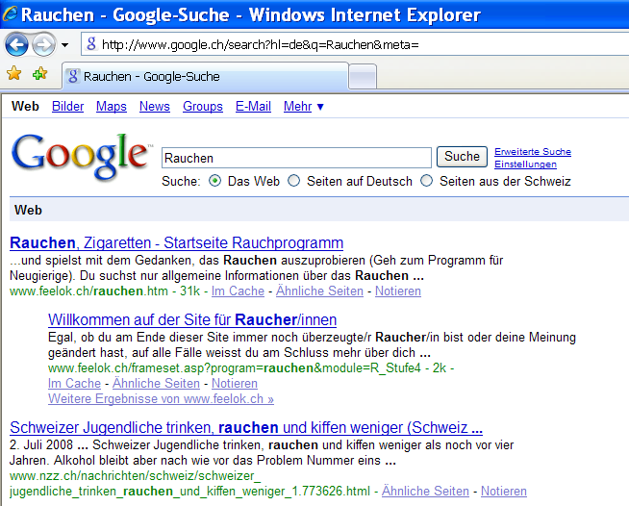
Fig. 3: If the keyword smoking is entered in «www.google.ch», feelok appears in the first as well as the second position of results (as per end of August 2008).

Two different approaches can be chosen to disseminate feelok:
- Specific topics or tools can be promoted (e.g. sport, nutrition or alcohol).
- The programme can be promoted as an entity.

The first as well as the second approach will help disseminating the whole programme as people will automatically see all topics offered through feelok once they enter the website. Users can then revisit the programme if they become interested in one of the other topics presented in feelok.

The budget

Between 1999 and 2008 feelok was financially supported by 5 institutions. These are the Cancer League of Zurich, the Baugarten-Foundation, the Swiss Network for Education and Health (Federal Office of Public Health), the Tobacco Control Fund, the Vontobel-Foundation and the Jubilee-Foundation of Credit Suisse. Over this period of nearly 10 years, 2 million CHF - corresponding to about 1.25 million Euro - were invested in feelok.

The feelok smoking prevention programme and its empirical results

Before feelok was developed in the year 1999, a needs assessment was conducted among teachers and young people. The results showed that feelok should become a multi-dimensional programme focusing on life style issues to be able to address the varying needs among the target group. feelok was therefore started with 3 other modules along with the smoking prevention programme: stress, self-confidence and sexuality. Studies consulted (Vollrath, 1998; Byrne & Mazanov, 2001; Si-Queira, Diab, Bodian und Rolnitzky, 2000) showed that smoking was often used as a strategy to combat stress, that a lack of self-confidence and self-esteem reduced the motivation and will to stop smoking and that human relationships and being lovesick play an important role in people's smoking behaviour. The feelok programme with its four different modules was thus a product where the findings of life style research were incorporated into the smoking prevention approach. Based on these considerations, feelok was developed from mid 1999 to the end of 2001 and the smoking prevention module was launched in the beginning of 2002.

Some selected findings of our research on the smoking prevention programme are presented below.

Percentage of smokers among the young population and among feelok users

According to the representative SMASH study ("Swiss Multicenter Adolescent Survey on Health", N=7,420, year 2002) between 17% (high school) and 30% (vocational school) of 16-year-olds in Switzerland smoke every day. The majority of adolescents doesn’t smoke.

In our study on the profile of feelok users, we placed a selection of questionnaire items from the SMASH study on the feelok starting page. The results showed that 16.5% of the feelok visitors aged 16 to 19 smokes every day.

Thus a sizeable segment of the young smokers can be reached through feelok, even though the non-smokers and those who smoke only occasionally are slightly overrepresented among feelok users.

Fig. 4: Answers to the question “Do you smoke?” in %. The question and answering categories are taken from the SMASH-study. The bars represent the results of the feelok study; the line shows the findings for 16 year-old smokers from the SMASH-study.

Motivation to stop smoking and motivation to start smoking
In the same study, respondents who smoked were asked to indicate whether they intended to stop smoking. Answers were grouped according to sex and age. Results show that less than 10% of the respondents are prepared to stop smoking within the next 4 weeks. About 40% do not want to stop smoking and 40% think they might stop at some time in the future.

Fig. 5: Answers to the question "Do you intend to stop smoking?" in % grouped according to sex and age.

Nearly 80% of respondents, who don’t smoke, show no interest in smoking. About 10% think they might try a cigarette at some stage and 10% think they might become occasional smokers.

Fig. 6: Answers to the question "Do you intend to start smoking?" in % grouped according to sex and age.

The stage-matched intervention of the smoking prevention programme – Structure and user statistics

Our studies show that feelok users are at different stages of change in terms of their smoking behaviour. This finding supports the notion of offering a stage-matched intervention programme.

The feelok smoking prevention programme is based on an extended version of the Transtheoretical Model of behaviour change (TTM). The original model developed by Prochaska et al. (1992) holds that people go through 5 stages of change from the problem behaviour (smoking with no intention to quit within the next 6 months) to the desired behaviour (non-smoking for at least 6 months). These stages can be described as follows:

- Pre-contemplation: There is no intention whatsoever to change the problem behaviour within the next 6 months.
- Contemplation: There is an intention to change the behaviour within the next 6 months.
- Preparation: There is a firm intention to reach the target behaviour within the next 30 days. Some authors hold that this stage entails first steps towards the target behaviour.
- Action: The target behaviour has been adopted yet only within the past 6 months.
- Maintenance: The target behaviour has been maintained for more than 6 months.

In terms of primary prevention among young people it is desirable to offer interventions not only to combat a problem behaviour but also to prevent it from developing in the first place. Therefore, the group around Prochaska extended the original TTM by a further 3 stages (Pallonen et al., 1998). These three stages are:

- Acquisition Pre-contemplation (APc): People at this stage do not have any interest in smoking.
- Acquisition Contemplation (AC): People at this stage consider starting to smoke within the next 6 months.
- Acquisition Preparation (AP): The imaginations about smoking have reached a stage where the person has a clear intention to start smoking.

Between the 3 stages of Acquisition and the 5 stages of Cessation there is an additional stage with young people who smoke occasionally independent of their motivation to change their behaviour.

The TTM does not only describe stages of behaviour change but also the factors that facilitate movement from one stage to another. These are the processes of behaviour change – the behavioural and the cognitive emotional processes -, the decisional balance and self-efficacy.

When the feelok smoking prevention programme was being developed, these 9 stages of the TTM and the factors related to the model were tested in a study with 700 adolescents in the canton of Zurich. Additionally, an extension of the model with further elements such as the feeling of helplessness, the barriers of stress, attitudes and social support (to name just a few) was suggested and tested in the same study. Based on the results of this study, the feelok smoking prevention programme was designed with 7 stages of behaviour change with a slightly changed algorithm. For interested readers, the report of this study can be downloaded in German on www.feelok.ch (Link: Infos über feelok -> Rauch- und Stressprävention bei Jugendlichen - Wissenschaftlicher Bericht)

Intervention modules for 7 different stages of change are offered in the smoking prevention programme to cater for the differing motivational needs of each group of adolescents. These modules target the following groups: 1) Young people who do not smoke and do not intend to start smoking 2) Young people who do not smoke but think they might try it out at some stage 3) Those who smoke occasionally 4) Regular smokers who do not intend to quit 5) Regular smokers who would like to quit 6) Young people who smoke regularly but are committed to give up 7) Young people who stopped smoking in the past. In addition, a section with general information about issues around smoking is offered.

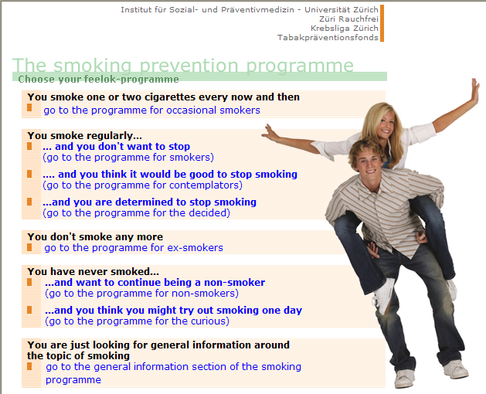
Fig. 7: The starting page of the smoking prevention programme. The intervention offers 7 stage-matched modules, based on the Transtheoretical Model of change, as well as a general section on issues around smoking.

Such a differentiated intervention approach is only useful if each module is being visited by the users. Our statistics involving more than 30,000 visits confirm that all 7 modules are of interest, yet to varying degrees. The highest proportion of visits was recorded for the module for non-smokers who do not want to try out smoking (27%). In second place was the module with information for adolescents who smoke and do not intend to stop (21%). According to the Transtheoretical Model of change, this corresponds to the stage of pre-contemplation. Such a proportion is to be rated as a considerable success as health promotion experience usually shows that it is very difficult to reach pre-contemplators. The fact that the smoking prevention programme is often used in class under supervision of the teachers may well explain this positive result. It is possible that these adolescents would not visit the smoking prevention programme if it was left up to them to do so in their free time.

Figure 8 shows the distribution of visits among the 7 stage-matched modules of the smoking prevention programme.

Fig. 8: Distribution of visits among the 7 stage-matched modules of the smoking prevention programme. Included are only visits that lasted at least 3 minutes (N=30,862).

Only visits to a module which last at least 3 minutes are considered as real visits. Shorter visits are not included in any of our statistics as it is not possible to gain useful information from a module in less than 3 minutes.

Sixty-one percent of the visits to the general section lasted at least 3 minutes. The average duration of these visits was 22.5 minutes.

Looking at the stage-matched modules of the smoking prevention programme, we see the following pattern: 43% of visitors to the section for smokers who think it would be good to stop smoking and 55% of the non-smokers stay for at least 3 minutes. For the other modules, the respective proportions of real visits lie somewhere in between those two extreme values.

Including only the real visits, we see an average duration of 14.6 minutes for smokers who think it would be good to stop smoking and 21.5 minutes for those who are determined to quit. The duration of visits to the other modules lies in between those two extreme values.

The following two figures show the results for all modules.

Fig. 9: Percentage of real visits (i.e. visits that last at least 3 minutes) per module (N=81,395)

Fig. 10: Average duration of visits for each of the smoking prevention modules (including only visits of at least 3 minutes duration, N=42,758)

Stage-matched intervention, general information about smoking and the needs of the target group

Scientific evidence of the 90ies indicated that stage-matched interventions to address smoking behaviour were more effective than interventions which did not differentiate according to the motivational stage of the target group (Butler et al., 1999; Dijkstra, DeVries and Roijakcers, 1999). Results from studies of the new century, however, partly challenge this notion (Riemsma et al., 2003; Bridle et al., 2005). When we conducted the study "Redesign of an Internet Program for Smoking Prevention as a result of new Findings", we were holding the assumption that stage-matched interventions were more effective. We were therefore concerned that 2/3 of the visits to the smoking prevention programme were recorded for the section of general information around smoking and only 1/3 of visits targeted one of the 7 stage-matched modules (user statistics of version 1 of the smoking prevention programme).

In order to motivate the adolescents to visit the stage-matched modules, the section with general information was removed in version 2 of the smoking prevention programme. However, the number of visits decreased from an average of 948 per month for version 1 to 650 for version 2.

Consequently, the decision was taken to re-integrate the section with general information yet the design of the starting page was changed (version 2.1). The link to the general section was now placed at the bottom of the page, after each link to the 7 stage-matched modules (see Fig.7). The re-integration of the general section resulted in an immediate increase in the number of visits from 650 for version 2 to 996 for version 2.1 (see Fig.11). The redesign of the starting page succeeded in directing more visitors to the stage-matched modules as now 72% of the visits were recorded for the stage-matched modules together compared to only 1/3 for version 1 of the smoking prevention programme (N=42,785).

It can thus be concluded that the majority of users are interested in the stage-matched information yet not all of them. Whatever the reasons may be, some users prefer to read information of general nature only and do not want to choose one of the motivational stages. If a general section is not offered, these users prefer to leave the website altogether.

Fig. 11: Monthly number of visits for version 1 of the smoking prevention programme (including the stage-matched modules and the general section), version 2 (stage-matched modules only) and version 2.1 (including the stage-matched modules and the reintegrated general section with a new design of the starting page).
Data collection version 1: September 03 – September 04 (N = 10,074)
Data collection version 2: January – April 05 (N = 3,264) – standardized data
Data collection version 2.1: Mai - June 05 (N = 3,279) – standardized data
Graph shows only visits of the smoking program, which last at least 3 minutes and max. 4 hours.
The number of visits to the feelok programme as a whole varied slightly between the periods of data collection for the three versions of the programme. This variation was accounted for by standardizing the number of visits, which was possible because the proportion of feelok users overall choosing the smoking prevention programme remained constant throughout the three evaluation periods.

The design of the effectiveness study of the smoking prevention programme

Currently, we are conducting an effectiveness study of the smoking prevention programme. Results are expected to be ready next year. The innovative design of this study is outlined below.

For the duration of one year, the link to the effectiveness study was placed on the starting page of feelok in a prominent position. If a person was interested in participating, he or she was informed that the aim of the study was to assess the health behaviour and user behaviour of the participants. He or she then filled in a short Internet-based questionnaire and left his/her email address (t0). Then the person could work with feelok. Those who did not want to participate in the study could surf freely on the feelok website.

Three days later, participants received an email asking them to fill in a second questionnaire, the intermediate questionnaire (tx). They thus answered for how many minutes they had worked with what module of feelok, whether they had used feelok at school under supervision of the teacher and who chose what topic they worked on (the student himself/herself or the teacher). One, six and twelve months later, participants received the follow-up questionnaire which was the same as the baseline questionnaire (t0).

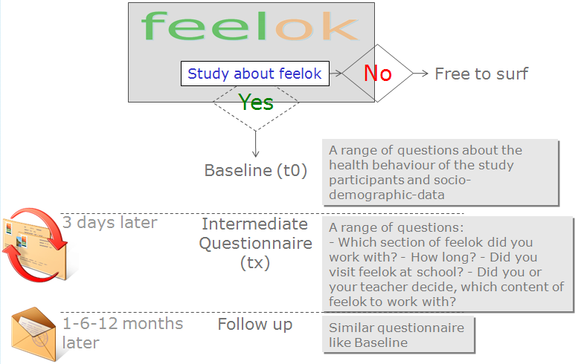
Fig. 12: Design of the effectiveness study of the smoking prevention programme

Based on the answers of the intermediate questionnaire, we can assign the participants to the experimental and control group. We will only analyse the data of the participants at school where the teachers decided which topics the youths had to work with. If the teacher decided that the study participant had to work with the smoking prevention program, we assign this participant to the experimental group. If the teacher decided that the participant had to work with another programme of feelok, we assign him or her to the control group.

What is special about this study is that the participants know they are part of a study yet they don't know which topic of feelok is being investigated. The questionnaire contains questions about all topics. Participants therefore cannot find out that the effectiveness of the smoking prevention programme is being evaluated. While participants are being assigned to the experimental or control group based on the teachers' decisions, teachers do not know that they are playing this role in the study. Possible biases due to individual interests in the topic of smoking are thus being excluded to a fair degree.

Other strategies to prevent smoking

The smoking prevention program is the main application of feelok to promote smoking abstinence. However, feelok offers other tools and services to help young people give up smoking. These are among others:

- The game "battle ships": This game aims to capture the adolescents' interest in all the topics offered by feelok (including smoking prevention). The player has to give correct answers to questions on any of the topics in order to be able to take a shot at the enemy's battle ships. The questions are linked with the corresponding information in feelok so that the player can always find the answers that help him succeed in the game. «The Link: www.feelok.ch/schiffeversenken»

- The "body talk" application in feelok offers a collection of interviews with adolescents on a range of topics including smoking, cannabis and drinking alcohol. Teachers can use these interviews and accompanying educational materials to discuss the respective topics in their class. «The Link: www.feelok.ch/bodytalk»
- Nearly all smoking prevention and health promotion projects face the problem that they need to invest a lot of resources in order to gain entry into the school system. feelok has integrated a project database for schools to facilitate the work of health project leaders. «Projects for schools» is a new platform that links service providers with decision makers at schools, which works as follows:
  - Health promotion projects are described in feelok.
  - Teachers and headmasters or headmistresses find information about different projects and the contact details of project leaders, which helps them implementing the projects of choice at their school.
Smoking prevention projects of external institutions can also advertise themselves through feelok in order to attract the schools' attention.
«The Link: www.feelok.ch/pDb.htm»

Future outlook: The new smoking prevention programme - version 3 and the concept of „shared applications“

With financial support of the Tobacco Control Fund, the current version of the smoking prevention programme is being evaluated by an external institution with a formative ex-post-evaluation with 12 school classes. Qualitative as well as quantitative methods are being used for this evaluation. Subsequently, ideas for the new smoking prevention programme will be tested with a formative ex-ante-evaluation among 6 school classes. Both studies will form the basis for the evidence-based development of the smoking prevention programme - version 3.

In addition, a steering group of representatives from institutions active in the field of smoking prevention will be formed. The development of the smoking prevention programme will be supervised by this group of experts.

What is innovative about version 3 of the smoking prevention programme is the concept of "shared applications": Attractive existing smoking prevention tools of other websites can be integrated into feelok. Likewise, feelok tools and services can be integrated into other Internet programmes. In this way, not only all partners but also the adolescents benefit: through a shared use of existing and new applications by various website providers, the cost of development is reduced and the probability that a higher number of adolescents becomes aware of these services is increased. A reduced cost and higher reach of the target group are the aims followed by the concept of shared applications.


The smoking prevention program
Website 1
Website 2
Website 3
Website 1
Website 2
Website 3

Fig. 13: The new smoking prevention programme of feelok is based on the concept of shared applications. Attractive existing tools of other websites are integrated into feelok and thus made available to its users. Likewise, feelok tools can be integrated into other Internet programmes. In this way, the probability that the smoking prevention tools become known to a higher proportion of adolescents increases. The whole concept can be realised with reduced financial resources.

Conclusion

Preventive measures are often focused on one behaviour only and offer very specific solutions. From the target person’s perspective, however, a “problem behaviour” is not an isolated unwanted phenomenon but is part of the person’s overall identity and life style – be it more or less coherent. This means that smoking prevention should also include measures which address further areas of a target person’s life, as shown with the following examples: A lot of smokers dread a weight gain after quitting. Smoking prevention should therefore include issues around nutrition and physical activity. People often smoke to relieve stress or to be social. The topics of stress and social competence are thus also relevant to smoking prevention. A lot of smokers take a cigarette as a reward, be it at the end of a working day or to combat boredom. Tangible and useful alternative strategies to achieve a better quality of life are therefore an important element in addition to various other smoking prevention strategies.

Smoking prevention thus needs to take a multi-dimensional approach involving interdisciplinary efforts. Smoking prevention experts need to work together with professionals in the areas of nutrition, physical activity, stress, self-confidence, quality of life, alcohol, human relationships etc. in order to be able to offer a comprehensive smoking prevention programme. Therefore, feelok was designed as a networking product which encompasses a variety of aspects related to smoking prevention.

feelok shows that it is possible to build a network comprising various institutions and develop a joint product which covers a variety of themes. Any single institution would not be able to offer such a programme alone. This fact is probably the most distinguished success of feelok which is responsible for the high frequency of visits and remarkable user statistics.

The institutional challenge for the future is to keep the network running as a flexible live organism despite the fluctuation of staff and frequently changing priorities in society. In addition to the institutional perspective, an eye has to be kept on the technical development of the Internet, and the product needs to be continuously adapted to remain attractive to adolescents and schools, even if the resources available may be limited. History shows that a popular Internet programme can be forgotten within a few years. Therefore, an Internet-based intervention does not only need to be updated by experts to keep the content at a professional level but also needs to be developed according to the changing possibilities of the Internet. Continuous involvement in “Internet” and “prevention” topics, long-standing expertise in relevant fields and a continuous upgrade of the product are thus necessary requirements to keep up the standard of the programme.

Contact
feelok
Institute for Social- and Preventive Medicine of the University of Zurich
Hirschengraben 84
8001 Zurich - Switzerland

Project leader
Oliver Padlina, PhD, MPH
opadlina@access.uzh.ch

Vollrath, M. (1998). Smoking, coping and health behavior among university students. Psychology and Health, 13(3), 431-441.
Byrne, D. G. & Mazanov, J. (2001). Self-esteem, stress and cigarette smoking in adolescents. Stress and Health: Journal of the International Society for the Investigation of Stress, 17(2), 105-110.
Si-queira, L., Diab, M., Bodian, C., & Rolnitzky, L. (2000). Adolescents becoming smokers: The roles of stress and coping methods. Journal of Adolescent Health, 27(6), 399-408.
Prochaska, J. O., DiClemente, C. C., & Norcross, J. C. (1992). In search of how people change: Applications to addictive behaviors. American Psychologist, 47(9), 1102-1114.
? Pallonen, U. E., Velicer, W. F., Prochaska, J. O., Rossi, J. S., Bellis, J. M., Tsoh, J. Y., Migneault, J. P., Smith, N. F., & Prokhorov, A. V. (1998). Computer-based smoking cessation interventions in adolescents: Description, feasibility, and six-month follow-up findings. Substance Use and Misuse, 33(4), 935-965.
Butler CC, Rollnick S, Cohen D et al. (1999). Motivational consulting versus brief advice for smokers in general practice: a randomized trial. British Journal of General Practice, 49, 611-616.
Dijkstra A, De Vries H, Roijakcers J. (1999) Targeting smokers with low readiness to change with tailored and nontailored self-help materials. Preventive Medicine, 28, 203-211.
Riemsma RP, Pattenden J, Bridle C. et al. (2003) Systematic review of the effectiveness of stage based interventions to promote smoking cessation. British Medical Journal, 326, 1175-1177.
Bridle C, Riemsma RP, Pattenden J et al. (2005). Systematic review of the effectiveness of health behavior interventions based on the transtheoretical model. Psychology and Health, 20, 283-301.

